Project Design Phase-II
Solution Requirements (Functional & Non-functional)

Date | 31 January 2025
Team ID | LTVIP2025TMID33796
Project Name | Enchanted Wings :
Maximum Marks | 4 Marks

Functional Requirements:
Following are the functional requirements of the proposed solution.
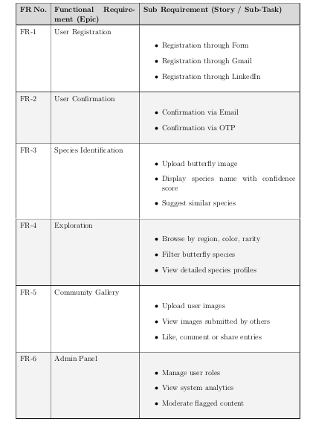

Non-Functional Requirement :

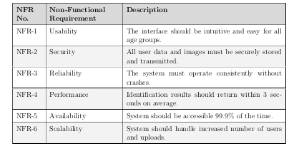
Following are the non-functional requirements of the proposed solution.

